CSC 134 Fall 2020
Homework Assignment 5
Total: 200 points
I do NOT debug for students. Solving assignment problems independently is one assessment criteria.
This homework allows students to practice the development of a database using MySQL.
Section 1
Using SQL, create tables according to the given schema shown in Figure 1. The ER diagram is shown in Figure 3. You must create your database using exactly the same names for tables and attributes, using the given type. The type of each attribute is defined in Figure 2. Note that this section is exactly the same as the one in Homework Assignment 4. You can use your Assignment 4 directly, or modify your Assignment 4 (if needed).

Customer (cid, name, address);
Orders (oid, order_date, cid) foreign key (cid) references Customer(cid);
Order_book(oid, isbn, no_of_copy) foreign key (oid) references Orders(oid), foreign key(isbn) references Book (isbn);
Publisher (pid, name, address, phone);
Book (isbn, title, btype, price, pub_date, pid)
foreign key (pid) references Publisher (pid);
Author (aid, fname, lname);
Written_by(isbn, aid)
foreign key (isbn) references Book (isbn), foreign key (aid) references Author (aid);
Editor (eid, fname, lname);
Edited_by(eid, isbn)
foreign key (isbn) references Book (isbn), foreign key (eid) references Editor (eid);

Figure 1 Schema

Customer (cid: CHAR(9), name: VARCHAR(20), address: VARCHAR(80));
Orders (oid: CHAR(9) , order_date: DATE, cid: CHAR(9))
Order_book(oid: CHAR(9), isbn: CHAR(10), no_of_copy:INT)

Publisher (pid: CHAR(10), name: VARCHAR(30), address: VARCHAR(80), phone: CHAR(10));
Book (isbn: CHAR(10), title: VARCHAR(100), btype: VARCHAR(15), price DECIMAL (10,2), pub_date: DATE, pid:CHAR(10));
Author (aid CHAR(4), fname: VARHAR(15), lname: VARHAR(15));
Written_by(isbn CHAR(10), aid CHAR(4));
Editor (eid CHAR(4), fname VACHAR(15), lname: VARCHAR(15));
Edited_by(eid CHAR(4), isbn CHAR(10))
Note: DATE is in the format of ‘yyyy-mm-dd’.
TIME is in the format of ‘HH:MM:SS’.
Figure 2. Type Definition

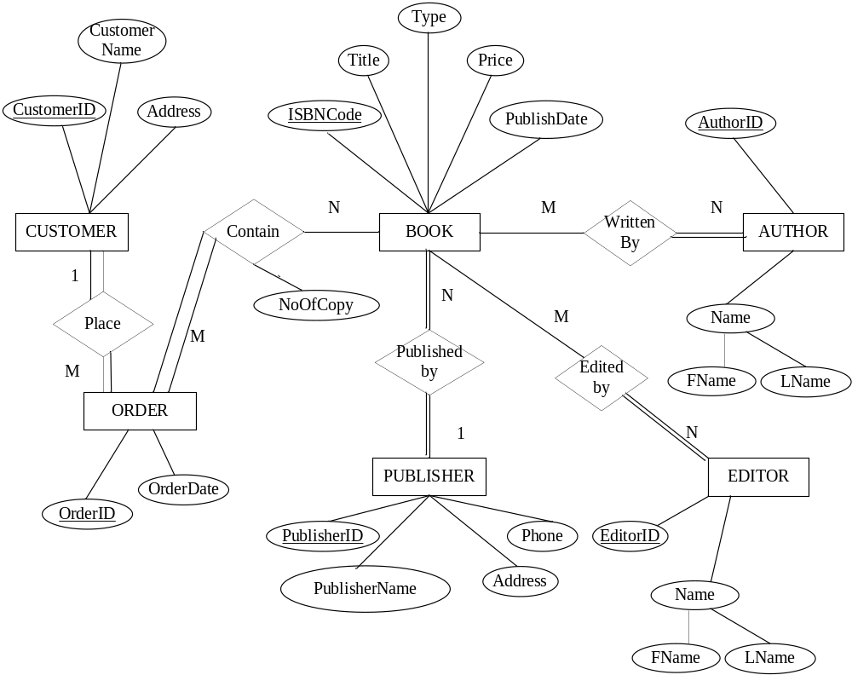

Figure 3 ER Diagram
Section 2
Populate the database. Please check sections 3 for details.
Section 3
Use SQL to specify the following queries. When you populate the database, insert data such that at least one row will be display as the result of running each query.

- Obtain information (editor id, editor first name, editor last name) of the editors who have edited the book whose ISBNCode is ‘8330418998’.
- Retrieve the customers’ names who bought novels. Order the result in the descending order of customer name. (Book type is novel).
- Get all publishers information (publisher name, address) which have published textbooks. If a publisher published more than one book, list the publisher only once in your result.
- Retrieve the author Id, author’s first name, author’s last name, and number of novel books written, if an author has written more than 2 novel books. Both sole-authoring and co-authoring activities should be considered as writing a book.
- Get authors information (first name, last name) who has written the book ‘Fundamentals of Database Systems’.
- Get the books information (title, type and ISBN) written by author ‘Jeff Smith’.
- Get information (publisher id, publisher name, phone) about publishers who have published more than 2 novels.
- Obtain the highest price of the books that are written by author “Jeff Smith”. List the price.
- List the editor Id and number of books edited, if the editor has edited more than 2 books. Both sole-editing and co-editing activities should be considered as editing a book.
- List all orders (order_id, order date) that ordered by customer named “Alice Kay”;
- List all books (ISBN, title, price) that are ordered by customer named “Alice Kay”. If she ordered the same book more than once or more than one copy, please only display the book once in the result. Order the result by book title in ascending order.
- List all the orders (order_no, order date) that include “Fundamentals of Database Systems”.
- List how many orders are placed before “2019-08-11’.
- For customers who had made more than 2 orders so far, list customer Id, customer name, and number of orders that the customer has made.
- Retrieve book (or books) that has(have) the highest price among all books. Please list book tile and price.

Section 4
Specify the statements to drop all the tables. Pay attention to the order of the drop statements in order to drop everything successfully. Note that this section is exactly the same as the one in Homework Assignment 4. You can use your assignment 4 directly, or modify your assignment 4 (if needed).

Submission
Submit the following files to Canvas. Note: Submit through any other ways, such as email attachment, will not be graded. Do NOT zip them.
You must execute the create, insert, drop statements and queries before your submission. 0 point will be given to each non-executable.

- *Create table statements (file name must be: 1_create_table.txt)
I will copy everything from this file and execute it. Make sure the tables are listed in the correct order such that I can execute it without any error. For any table that cannot be created, you will lose 40 points, even if the error caused by the incorrect order of creating table.
- Insert statements to populate database (file name must be : 2_populate_db.txt)
- Queries (file name must be: 3_query.txt)
- *Statements to drop all tables (file name must be: 4_drop_all.txt)
- An output file showing query results (file name must be: 5_output.pdf). In this file, for each query, you must:
  - Include the number and query description (e.g Query 1: Obtain information ….)
  - Your SQL query (e.g. select… from…)
  - The result of running this query (screen shots is required).

